

**YEAR: 9**

**SUBJECT: SCIENCE**

**TEST: Chemical reactions**

**TIME: 45 mins**

**QUESTIONS: Part A: Multiple Choice Questions (6 marks)**

**Part B: Short Answer Questions (35 marks)**

**TOTAL MARKS: 41 marks**

**DO NOT WRITE ON OR MARK THIS PAPER**

**SECTION ONE: Multiple Choice Questions (1 mark each)**

**Answer this section on the separate multiple – choice answer sheet**

1. The law of conservation of mass explains why, in a chemical reaction:
   1. energy cannot be created nor destroyed, only transformed or transferred.
   2. the total mass of reactants equals the total mass of products.
   3. new atoms are created from the reactant atoms.
   4. when rearranging atoms to form products, the mass changes significantly.
2. A chemical equation shows:
   1. the chemical formulas of the reactants and products.
   2. the names of the reactants and the products in words.
   3. all the atoms in the compounds of the reactants, but not the products.
   4. all the atoms involved in the reaction and how they rearrange into the products.
3. Copper reacts with sulfur dioxide to form copper sulfide and oxygen gas. The reactants for this reaction are:
   1. copper
   2. copper and sulfur dioxide
   3. copper sulfide and oxygen gas
   4. copper, sulphur dioxide, copper sulfide and oxygen gas
4. When petrol explodes, it releases energy in the form of heat and light. This reaction is an example of:
   1. an endothermic reaction
   2. an exothermic reaction
   3. a neutralisation reaction
   4. an extrathermic reaction
5. Neutralisation reactions between acids and bases can be generalised by which one of the following word equations?
6. acid + base → hydrogen gas + salt + water
7. acid + base → water
8. acid + base → salt + water
9. acid + base → salt + carbon dioxide + water
10. Which of the following chemical equations is correctly balanced?
    1. HCl + NaOH → NaCl + H2O
    2. H2 + O2 → H2O
    3. 2Na + H2O → 2NaOH + H2
    4. CaCl2 + PbCO3 → 2PbCl2 + CaCO3



**SEMESTER Two 2017**

**Chemical reactions:**

**ANSWER BOOKLET**

**NAME:**

**FORM:** **DATE:**

Multiple Choice Short Answer Total

**/38**

**/32**

**/6**

**SECTION ONE:** Multiple choice answers

Cross (X) through the correct answer.

|  |  |  |  |  |
| --- | --- | --- | --- | --- |
| 1 | a | **X** | c | d |
| 2 | a | **X** | c | d |
| 3 | a | **X** | c | d |
| 4 | a | **X** | c | d |
| 5 | a | **X** | c | d |
| 6 | **X** | b | c | d |

**SECTION TWO: Short Answer (35 marks)**

Answer the questions in the spaces provided.

**Question 5 (4 marks)**

Ethane (C2H6) reacts with oxygen gas (O2) to form carbon dioxide (CO­2) and water vapour (H2O).

**a)** **Identify** the reactants of this reaction.

**b)** **Identify** the products of this reaction.

**c)** **Construct** a word equation for this reaction.

**d)** **Construct** an unbalanced formula equation for this reaction.

a. Reactants : ethane + oxygen gas – (1 mark)

**b** Products : carbon dioxide + water vapour – (1 mark)

**c** ethane + oxygen → carbon dioxide + water vapour – (1 mark)

d C2H6 + O2 → CO2 + H2O – (1 mark)

**Question 6 (5 marks)**

Magnesium burns in oxygen gas to form magnesium oxide. Its unbalanced formula equation is:

Mg + O2 → MgO

1. **Use** this equation to **identify** the chemical formula for magnesium oxide.
2. **Construct** a word equation describing this reaction.
3. **Identify** which element (Mg or O) is unbalanced in the above equation.
4. **Balance** the above equation.
5. **Identify** the type of reaction that has taken place.

a .MgO – (1 mark)

b. Magnesium + oxygen gas → magnesium oxide – (1 mark)

c. O is unbalanced – (1 mark)

d. 2Mg + O2 → 2MgO – (1 mark)

e. Combustion reaction or if someone writes corrosion reaction give – (1 mark)

**Question 7 (4 marks)**

**Balance** the following chemical equations:

**2**

**2**

**3**

1. 

**2**

1. 

**2**

**2**

**6**

**3**

1. 

**4**

**7**

**2**

**6**

1. 

**Question 8 (4 marks)**

The graph below shows the change in energy that occurs during a chemical reaction.

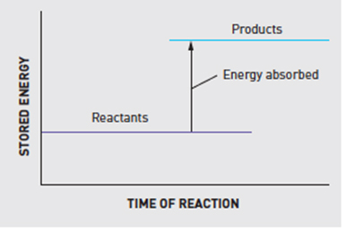

1. Is this an endothermic or an exothermic reaction? (1 mark)

Endothermic

1. Explain why you chose your answer for part a) above. (2 marks)

Endothermic reactions absorb energy – 1 mark

Graph shows reactants absorbing energy to form product – 1 mark

1. Where does the energy that is released in an exothermic reaction come from? (1 mark)

Come from the breaking and forming of chemical bonds – 1 mark

**Question 10 (5 marks)**

Use this graph to answer the following questions:

Increasing volumes of sodium hydroxide (NaOH) were added to a solution of hydrochloric acid (HCl). As it was added, the pH changed according to the graph shown below.

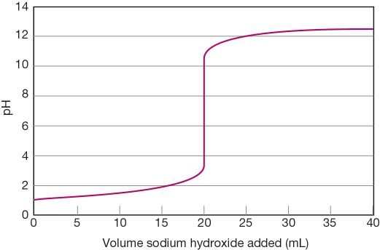

1. State the pH of the solution at the start of the experiment.
2. Determine the volume of sodium hydroxide that is needed to be added to exactly neutralise the acid.
3. Determine the pH when 16 mL of sodium hydroxide was added.
4. Determine the total volume of sodium hydroxide added in the experiment.
5. At the end of the above experiment, what type of solution was formed?

**a) pH of 1 –** (1 mark)

**b) 20mL –** (1 mark)

1. **pH 2 –** (1 mark)

**d) 40 mL –** (1 mark)

**e)The solution becomes ALKALINE/BASIC –** (1 mark)

**Question 11**

Acids are commonly found around us. Bases can be described as the ‘chemical opposite’ of acids.

1. List the main properties of **acids** and **bases**. (4 marks)
2. What is the difference between a strong and a weak acid? (2 marks)

a) Acids – Any four properties, some examples are given below ( ½ mark each)

1. Have a sour taste
2. Produces a prickling or burning sensation when they come into contact with the skin or they are corrosive
3. They all contain at least one hydrogen atom
4. They tend to react with many metals and releases hydrogen gas and a salt

Bases – Any four properties, some examples are given below ( ½ mark each)

1. They are bitter and feel slippery or soapy to touch
2. They react with fats and oils to produce soaps
3. Some bases can dissolve in water and are called as alkalis
4. They are neutralised by acids producing a salt and water
5. Strong acids are dangerous because they can burn through objects. (1 mark)

Weak acids are much safer as we can eat and drink some of them. (1 mark)

Please check your work / complete any unanswered questions.